

Dr. Brittany, Myers inc.
2018-03-18
Dr. Myers
9419 Sherri Wall, Katherinemouth, MA 67522
Phone: 807378348
Fax: 5138572613

Re: Joanna, Garcia
PHN: 27922795
Birthdate: 01-May-1945
Address: PSC 3586, Box 6273, APO AE 84947
Patient number: 8080319534

To Whom It May Concern:

This is a medical letter to state the above patient is pregnant with expected delivery date of 15-Apr-2025. Hoping this information is satisfactory for your requirements.

Thank you.

Sincerely,
Dr. Brittany, Myers
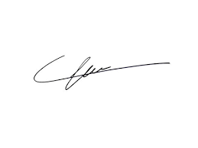
FRCS© NCMP
Clinical Assistant Professor, UBC
Department of Obstetrics and Gynecology SMH

